Batch: C1 Roll No.: 16010122221

Experiment No. 6

Grade: AA / AB / BB / BC / CC / CD /DD

Signature of the Staff In-charge with date

Title: User interface design using UI tools for mini project
______________________________________________________________________
Aim: To enable the students learn different user interface design tools and their aspects
______________________________________________________________________

CO: Prepare the System Design and Model ______________________________________________________________________

Books/ Journals/ Websites referred:
- Roger Pressman, “Software Engineering”, sixth edition, Tata McGraw Hill.
__________________________________________________________________
Pre Lab/ Prior Concepts:

The user interface Need:
System users often judge a system by its interface rather than its functionality. A poorly designed interface can cause a user to make catastrophic errors. Poor user interface design is the reason why so many software systems are never used. Most users of business systems interact with these systems through graphical interfaces although.
GUI characteristics
Windows Multiple windows allow different information to be displayed simultaneously on the user’s screen. Icons different types of information. On some systems, icons represent files; on others, icons represent processes. Menus Commands are selected from a menu rather than typed in a command language. A pointing device such as a mouse is used for selecting choices from a menu or indicating items of interest in a window.
GUI advantages
They are easy to learn and use.
• Users without experience can learn to use the system quickly
The user may switch quickly from one task to another and can interact with several different applications.
Information remains visible in its own window when attention is switched.
Fast, full-screen interaction is possible with immediate access to anywhere on the
User Interface Design Models
User model — a profile of all end users of the system
Design model — a design realization of the user model
Mental model (system perception) — the user’s mental image of what the interface is
Implementation model — the interface “look and feel” coupled with supporting information that describe interface syntax and semantics
User interface design analysis:
The overall process for analysing and designing a user interface begins with the creation of different models of system function (as perceived from the outside). You begin by delineating the human- and computer-oriented tasks that are required to achieve system function and then considering the design issues that apply to all interface designs. Tools are used to prototype and ultimately implement the design model, and the result is evaluated by end users for quality.

Study and describe any one user interface tool.

Studied and used Figma for designing the UI of our application.

Figma is a popular user interface (UI) design and prototyping tool that has gained widespread use in the design industry. It is a web-based application, which means it is accessible through a web browser, and it's particularly known for its collaborative features. Below is a detailed description of Figma as a user interface tool.

1. User Interface Design:

Vector-Based Editor: Figma provides a vector-based design interface that allows designers to create scalable and high-quality graphics. Users can design icons, illustrations, and UI components with precision.

Artboards: Like other design tools, Figma uses artboards to represent the canvas for different screens or states of an interface. Designers can create multiple artboards within a single project.

Real-Time Collaboration: One of Figma's standout features is its real-time collaboration capabilities. Multiple users can simultaneously work on a design file, making it easy for teams to collaborate, provide feedback, and iterate on designs in real time.

Auto Layout: Figma's Auto Layout feature simplifies the creation of responsive designs. Designers can set rules for how components and elements should resize and reposition based on changes in content.

2. Prototyping and Interaction:

Prototyping Tools: Figma offers tools for creating interactive prototypes. Designers can define transitions, gestures, and interactions to simulate how a user will navigate through the UI.

Presentation Mode: Designers can use Figma's presentation mode to showcase their designs, demonstrating how the interface will look and function to stakeholders and clients.

3. Collaboration and Sharing:

Sharing and Permissions: Figma allows users to share design files with others, and designers can control permissions to determine who can view, comment, or edit the files.

Comments and Feedback: Collaborators can leave comments on specific elements within the design, and Figma provides a thread-like system to manage feedback and discussions.

4. Version Control:

Figma keeps track of version history, allowing designers to revert to previous iterations of their design. This feature is valuable for maintaining a design history and making comparisons.

5. Integrations:

Figma offers integrations with various design tools, project management platforms, and developer handoff tools, enhancing the workflow for design teams.

6. Cross-Platform Access:

Figma is available as a web-based application and as a downloadable desktop application for macOS and Windows. This accessibility allows designers to work from various devices and operating systems.

7. Plugins:

Figma supports a wide range of plugins that extend its functionality. These plugins can help designers streamline their workflow, automate tasks, and access additional design resources.

UI prototype of our app on figma can be checked here :

https://www.figma.com/design/NiKyjqqV5aQCrhM6FfO1JM/Code_Runner?node-id=0-1&t=7qBWK9bkk394PV3h-1

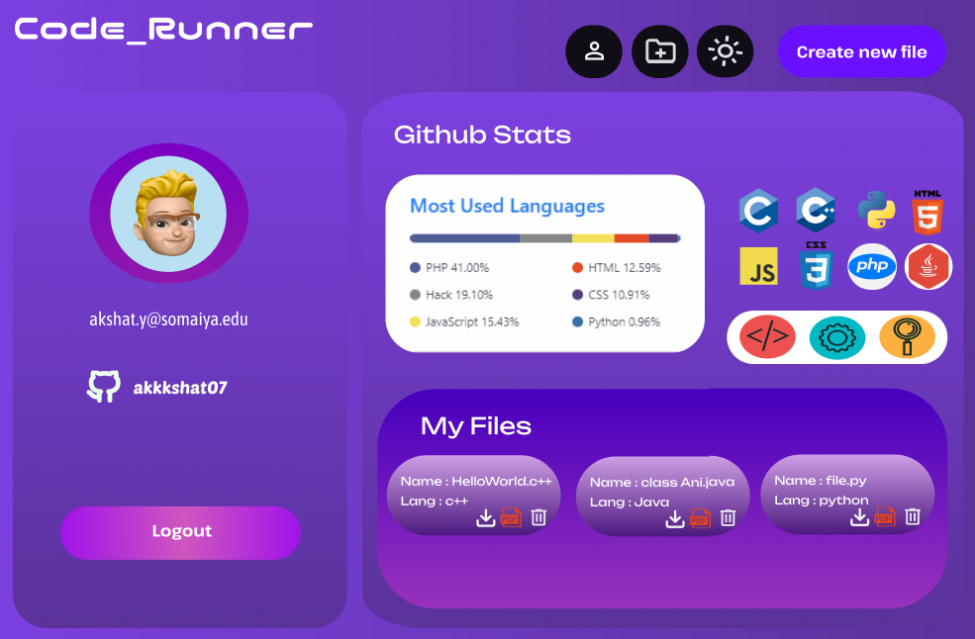
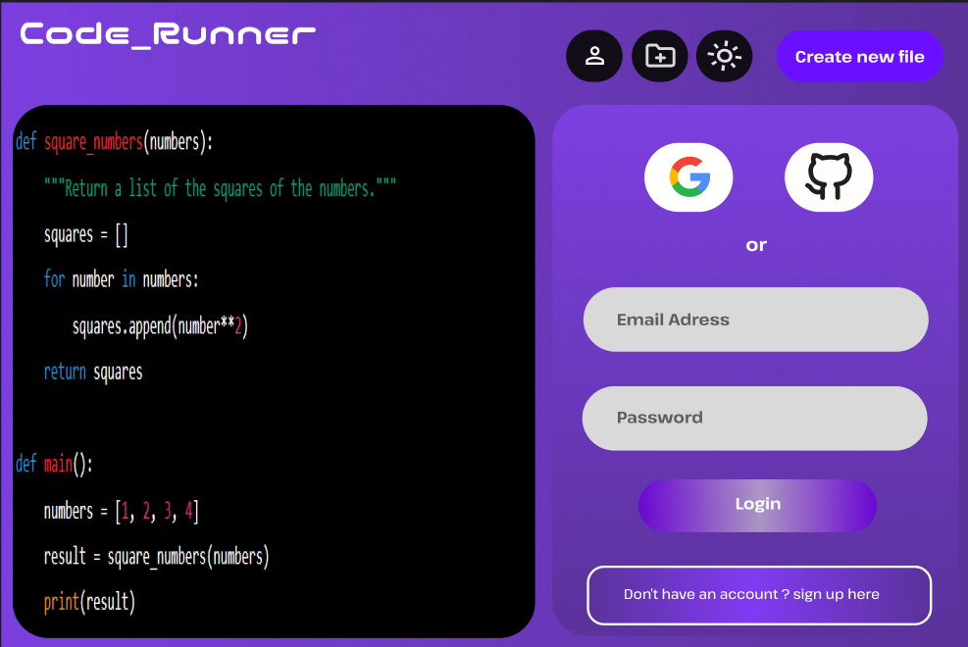

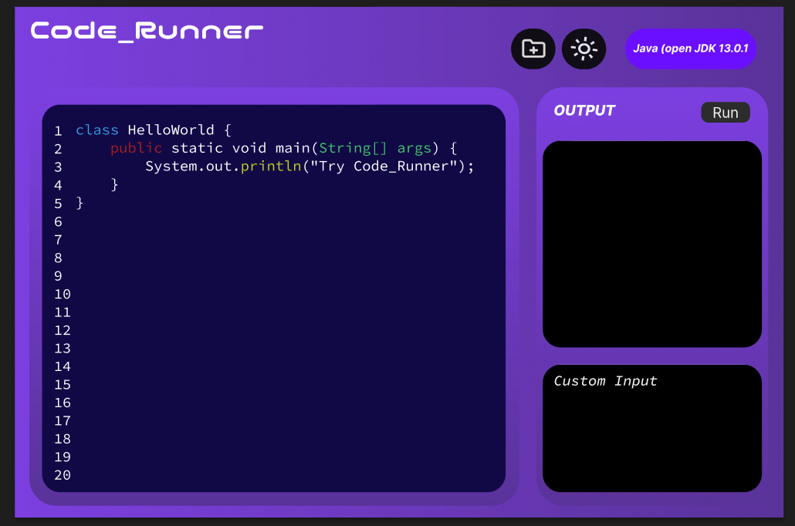

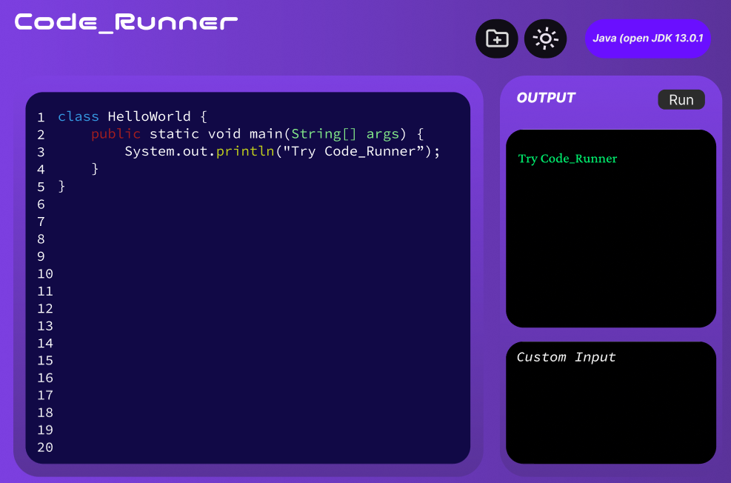

CONCLUSION:

Post Lab Descriptive Questions
- State various types of UI design tools.

Graphic Design Software: Adobe Photoshop, Adobe Illustrator
Wireframing and Mockup Tools: Balsamiq, Sketch, Adobe XD, Figma, InVision
Prototyping Tools: Axure RP, Marvel, Proto.io
Code-Based UI Tools: HTML/CSS/JavaScript, React, Vue, Angular
Icon and Illustration Design Tools: Adobe Illustrator, IconJar, Sketch (with plugins)
Design Systems and Component Libraries: Framer X, Zeplin
Usability Testing and Analytics Tools: UserTesting, Hotjar
Augmented and Virtual Reality Design Tools: Unity, Adobe Aero

